**CASE STUDY 1 REPORT**

**Group Name:** Avengers

**Group Members:**

Mell Edzan Bin Mustapha

Noratysha Abidin

Tunku Shahrin Iman

**Project Title: Ames Housing Dataset**

**Task & Roles:**

Pre-processing:

- Removing outliers

- Identifying and fixing missing values

- Encoding

Machine Learning:

-Machine Learning Design (Mell, Tysha, Shahrin)

-Testing (Tysha, Shahrin)

Deployment:

-Web App Design (Mell,Shahrin)

Documentation:

-Slides (Mell, Tysha, Shahrin)

-Demo (Mell)

**Timeline** 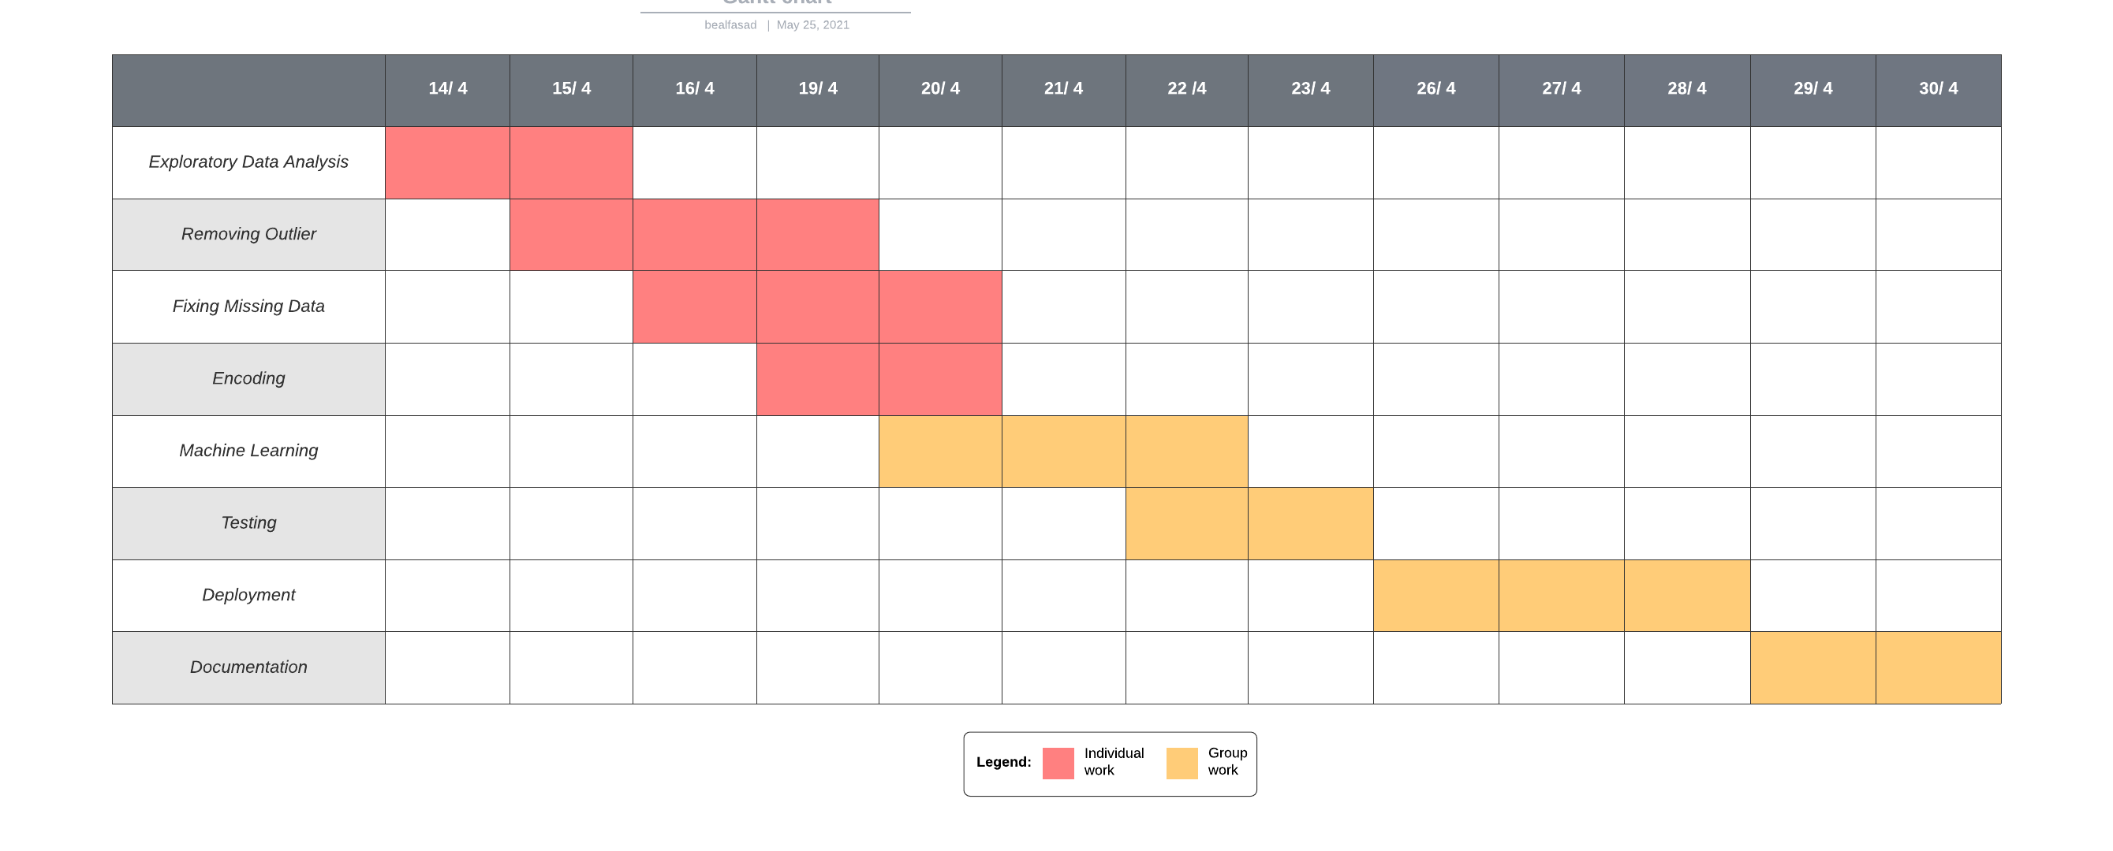

**Issues:**

-Some team members used different library for their visualizations. (Eg: missingno)